**Phase 3 – Part 2: View-Based Questions**

### **View Creation**

**SQL Statement:**

CREATE OR REPLACE VIEW ProductionHouseInvestmentView AS

SELECT

ph.PId AS ProductionHouseId,

ph.Name AS ProductionHouseName,

COUNT(i.MovieId) AS TotalMoviesProduced,

ROUND(AVG(m.TotalCost), 2) AS AvgInvestment

FROM PRODUCTION_HOUSE ph

JOIN INVESTED_BY i ON ph.PId = i.ProductionHouseId

JOIN MOVIE m ON i.MovieId = m.MovieId

GROUP BY ph.PId, ph.Name;

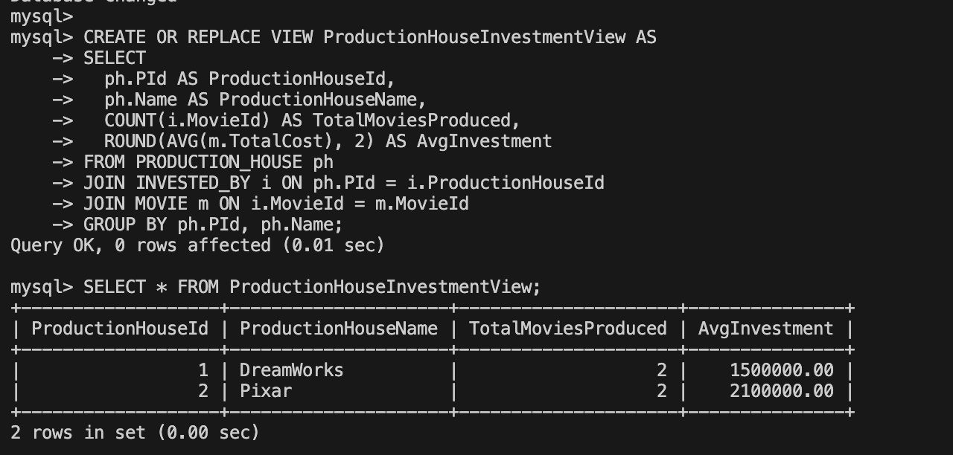

**Query 1: Production house with maximum average investment**

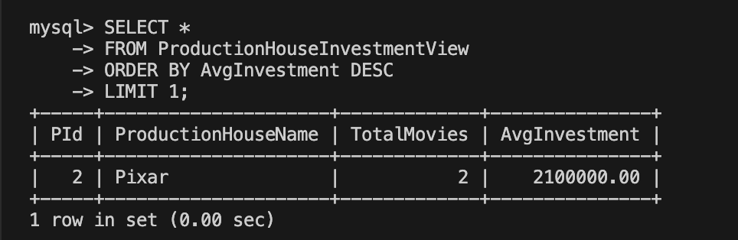

**Query 2: Total movies produced & average investment per production house**

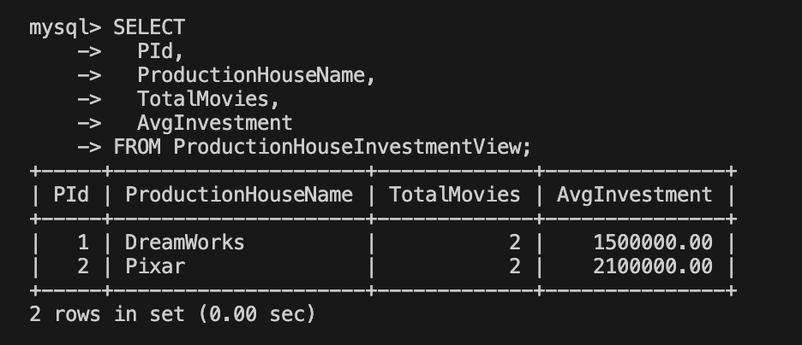

**Query 3: Minimum, maximum, and average investments across all production houses**

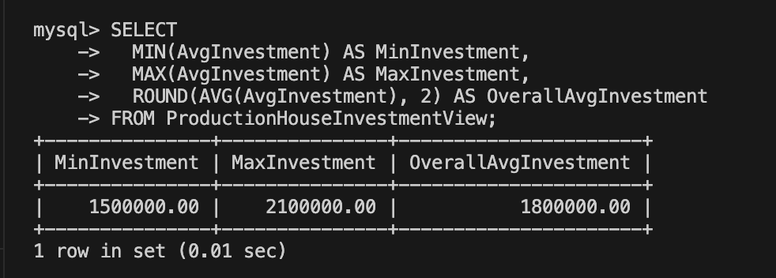

**Query 4: Production houses sorted by total number of movies (descending)**

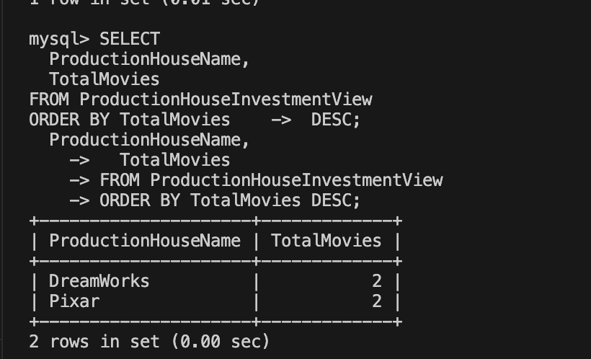

**Query 5: Total production houses, total movies, average investment overall**

